Title (Arial, Font 18, Bold)
Graham Bell¹, Albert Einstein² and Erwin Schrödinger³ (Arial, Font 8.5)
¹School of Mechanical and Aerospace Engineering, Seoul National University, Seoul, 00000, Korea, ^{2,3} Faculty of Engineering, University of Vienna, Karl-Lueger-Ring 1, Vienna, Austria (Arial, Font 8)

(Received 000 0, 2020; Revised 000 0, 2020; Accepted 000 0, 2020) -please leave blank

Keywords: At least four keywords; In alphabetical order; Separated by semicolon; Design of experiments (Arial, font 7, upper case at the beginning of each keyword)

Correspondence to: Please Fill In (e.g. Erwin Schrödinger) / Please_fill_in@email.ac.kr
----------------------------------------------------------------------------------------------------------------------------------------------------------------------------------------------------------------------------------------------------------------------------------------------
Abstract Abstract must be written in Arial, font 9.5. Abstract should not exceed 150 words. In present study, as a basic step for modeling the fatigue behavior of an extruded Al alloy cylinder, the fatigue crack growth data of the alloy was collected in two orientations. Microstructural analysis revealed that the material had recrystallized grains and clusters of constituent particles aligned in the direction of extrusion. Fatigue life of the samples revealed a shorter fatigue life representing a higher fatigue crack growth rate in transverse direction.

----------------------------------------------------------------------------------------------------------------------------------------------------------------------------------------------------------------------------------------------------------------------------------------------

1. Introduction (Arial, Font 12, Bold)
This document is a template for Microsoft Word. Please do not use other templates.
The author(s) must follow instructions strictly in order to maintain the high standard of the journal.
The paper is divided into three parts. The first part includes the title, author’s name, abstract, and keywords. The second part is the main body of the paper that includes the references and nomenclature. The third part is the author’s profile. Author’s affiliation and the address of affiliation should be included.
The main text must be written in Arial, font 9.5, and line spacing of 12 points. The font size, line spacing, and margin of the template must not be altered.
References should be listed at the end of the paper and arranged in order. References should be cited in the main text by numerals in a square bracket [1-3].

2. Section (Arial, Font 12, Bold)
2.1 Subsection (Arial, 11, Italic, Bold)
The second part consisting of the paper body must be edited in double column format. Figures and tables should be located at top or bottom of either column. Clear original figures in black and white should be used. Equations should be numbered consecutively throughout the paper and located at the right margin as in Eq. (1) below. Figures and tables should be placed at the top or at the bottom of each column as in Fig. 1 and Table 1.

Table 1. Material properties of SCP10.

Young’s modulus (GPa) | 210
Poisson’s ratio | 0.3
Yield Strength (MPa) | 433
UTS (MPa) | 460

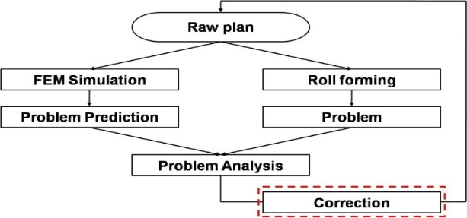

Fig. 1. Flow chart for the correction of the roll forming process design.
For instance, Eq. (1) is used to calculate a response surface as follows:

(1)
(2)

where xi denotes the design variables, nd is the number of design variables, βi is the unknown coefficient, and denotes the design matrix comprising experimental points. The settings of the font size to prepare the equations are:
Main equation: 9.5 pt (Times New Roman),
Subscript/superscript: 6 pt (Times New Roman),
Sub-subscript: 5 pt (Times New Roman),
Symbol: 18 point,
Sub-symbol: 12 point.

3. Conclusions
Clarity of all figures is extremely important. If the final version is not prepared in two-column format or does not include author(s)’ biographies, the publication process will be delayed. The DOI number will be assigned by the journal office. The “manuscript received,” “revised” and “accepted dates” will be checked and corrected by the journal office.

Acknowledgments
This work supported by Research Program supported by the Department of Education and Technology (program name), Country Name.

Nomenclature------------------------------------------------------------------
E : (Effective) work potential
E₀ : Exergy
E₀₀ : Energy of a system
K : Kelvin temperature scale
S : Entropy
T : Temperature or Celsius temperature scale
W : Effective work

References
References (in font 9) should appear with items referred to by numerals in square brackets. All journal articles must include volume, number, and pages. The journal title, conference title, and book title must be in italic.

- C. S. Kim, K. S. Hong, and M. K. Kim, Nonlinear robust control of a hydraulic elevator, Control Engineering Practice, 13 (6) (2005) 789-803.
- R. S. Chandel and S. R. Bala, Effect of welding parameters and groove angle on the soundness of root beads deposited by the SAW process, Proc. of Trends in Welding Research, Gatlinburg, Tennessee, USA (1986) 479-385.
- S. Kalpakjian and S. R. Schmid, Manufacturing Processes for Engineering Materials, 2nd Ed. Addison-Wesley Publishing Company, New York, USA, (1992).

Author information

Brief biographies and photos (25 x 30 mm) of authors must be described. Authors are required to follow the style of writing the author’s biography as below.

A picture and short bio of less than 100 words must be included. Author’s name is in Arial 9.5 bold font. Other words are in Arial 9.5 regular font. Please be informed that the corresponding author’s bio must be included. Others are optional. (e.g. Graham Bell is a post doctor of the School of Mechanical and Aerospace Engineering, Seoul National University, Seoul, Korea. He received his Ph.D in Mechanical Engineering from Seoul National University. His research interests include nanofluids, modern heat transfer and space propulsion.)

